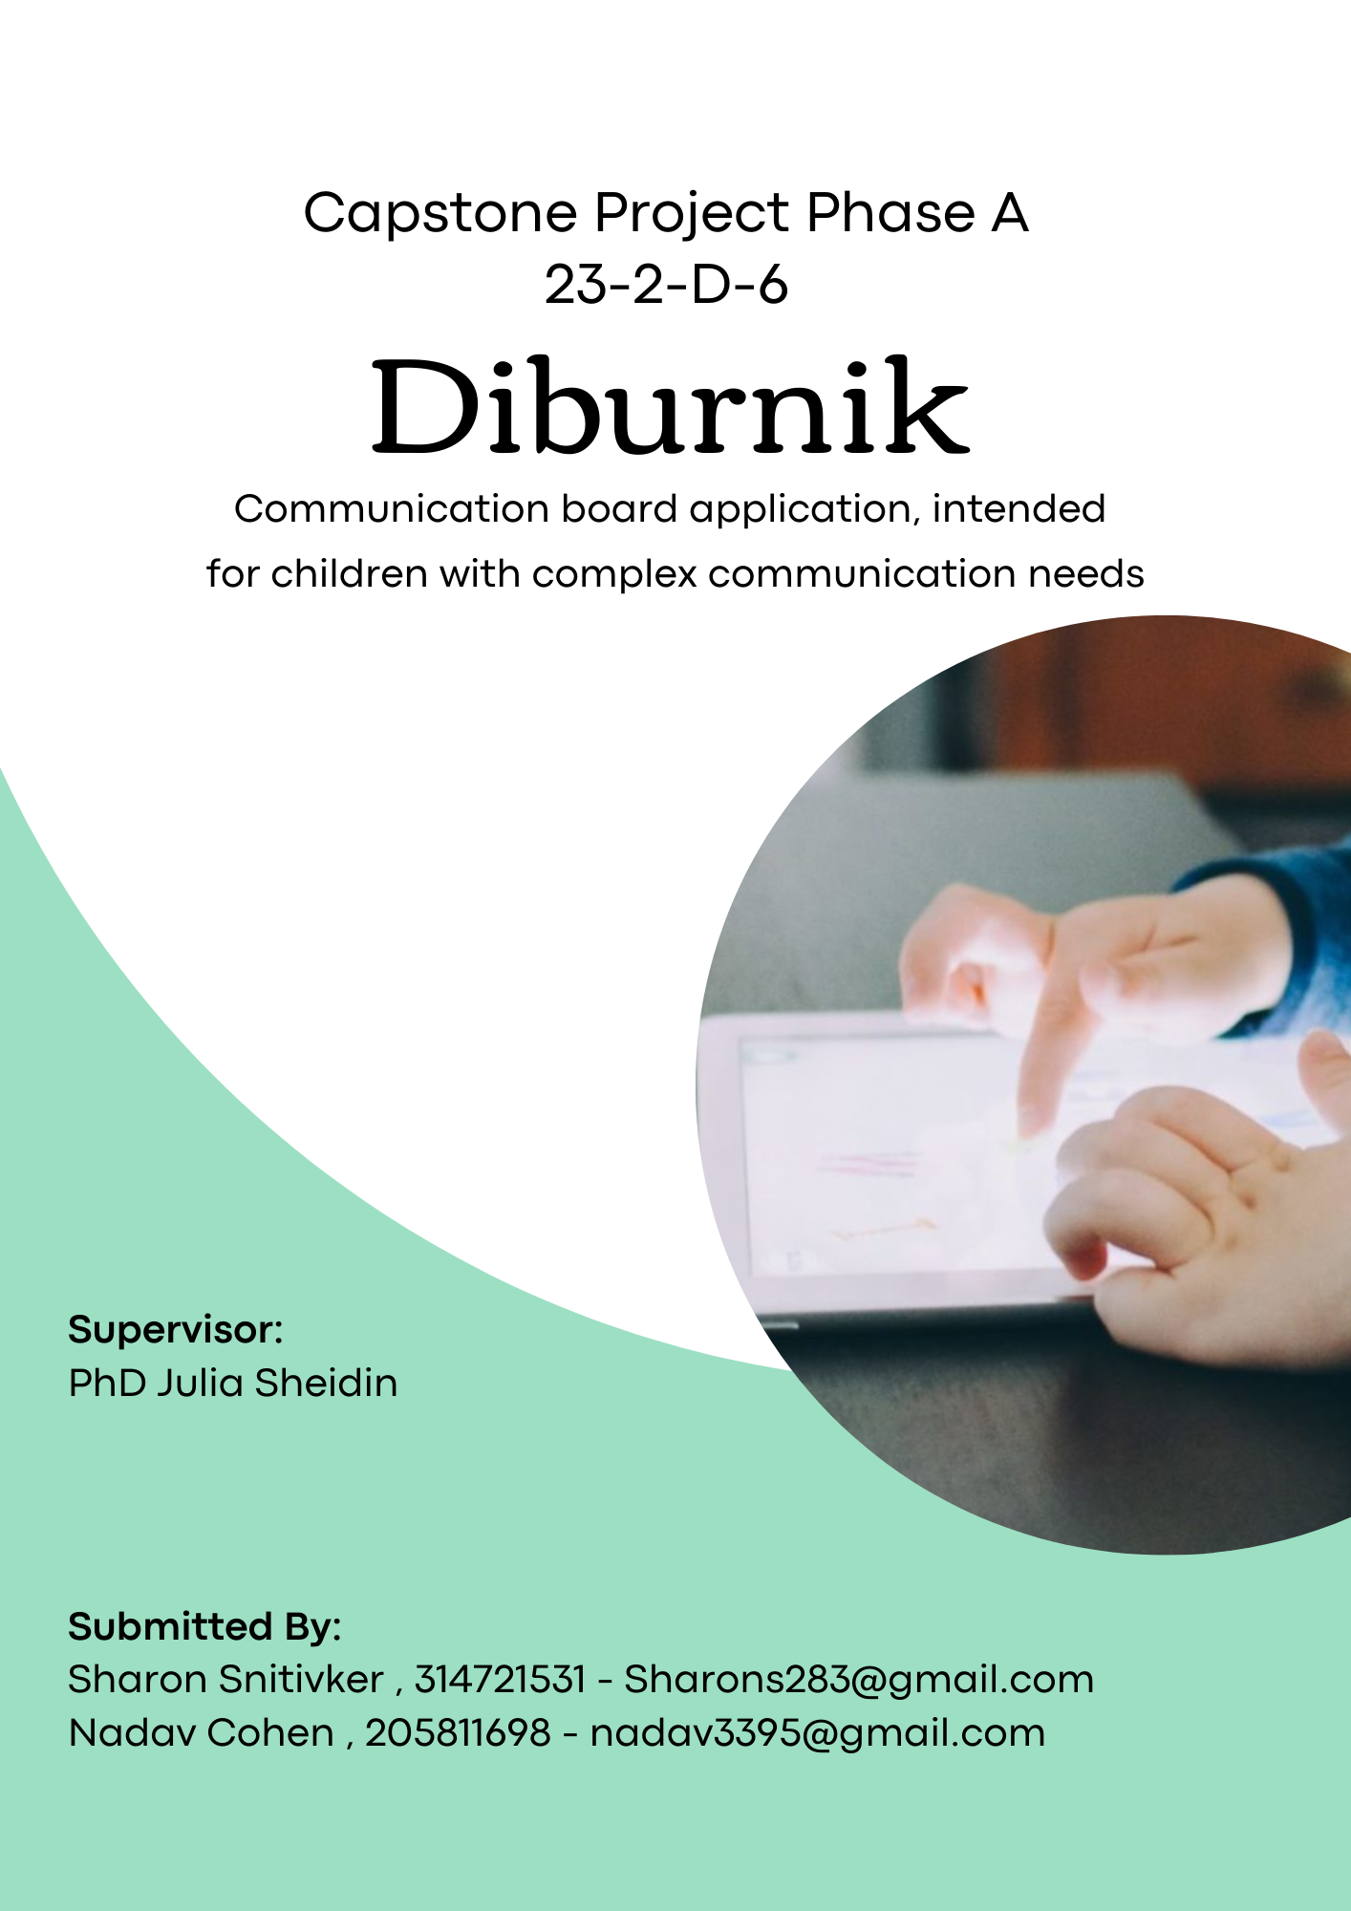

**Table of Contents**

1. Abstract 2

2. Introduction 3

3. Background and Related Work 5

3.1. Background 5

3.1.2 Semantic Communication Boards 6

3.2. Related Work 8

4. Expected Achievements 10

5. Research and Engineering Process 12

5.1. Process 12

5.2. Product 14

5.3. Diagrams 14

5.3.1. Use Case 14

5.3.2. Activity Diagram 17

5.3.4. GUI Prototype 18

6. Evaluation / Verification Plan 30

6.1 Testing Plan 30

6.2 Evaluation by User 32

7. References 33

# 1. Abstract

People experience communication difficulties for a range of reasons, including learning/intellectual disabilities, autism spectrum disorder (ASD), brain injuries, cerebral palsy (CP) and motor neuron disease. Digital solutions, such as communication boards, have been proven helpful in getting the message from those unable to speak or even write through conventional methods. However, most commercial digital boards are simply unaffordable for most families.

While AAC has been widely studied and utilized for individuals of all ages, in our project we will be primarily focused on children. We aim to develop an improved Alternative Communication (AAC) Board application, that will combine a set of unique features in order to best fit the needs of children with complex communication needs (CCN), designed to be used on both tablet and phone devices.

Our main project goal is to help children with different levels of CCN to enhance their communication and language (Hebrew) abilities. We aim to do so by empowering the frequency in which they will independently initiate requests to express their desires, needs and feelings using our application. Furthermore, our application will not only serve as a standard communication board but will also function as an educational platform that will enable each child to practice and develop his language and communication skills. Additionally, we will provide parents, educators, and speech therapists with valuable insights about the children's progress.

**Keywords**: Complex Communication Needs (CCN), Augmentative and Alternative Communication (AAC), Communication Board, Educational Platform, Children, Progress, Tablet.

# 2. Introduction

Many children with complex communication needs (CCN) resulting from a wide range of developmental disabilities such as: autism spectrum disorders, cerebral palsy, down syndrome, and other special needs often do not develop speech and language skills as expected. Their speech abilities may be limited, they might experience delayed speech development or have speech that is difficult to understand. These communication challenges can result in them being severely restricted in their ability to communicate effectively with others and leave their needs and wants unknown.[3]

Communication boards are a distinct category within the broader field of Augmentative and Alternative Communication (AAC) [1] tools, encompassing a range of both low-tech and high-tech variants. Low-tech communication boards offer non-electronic communication methods and typically involve the use of physical boards or books containing symbols, pictures, or words that can be pointed to or selected by the user. On the other hand, high-tech communication boards employ computer-based solutions that effectively function as the user's "voice" by generating digitized, synthesized, or recorded speech in response to the user's input.

Extensive research provides compelling evidence that children with complex communication needs (CCN) experience significant advantages in their communication, language, and literacy skills through the use of augmentative and alternative communication (AAC). Importantly, AAC interventions carry no risks for their speech development.[3]

The currently available communication boards for children with CCN either lack support for Hebrew language, some applications exclusively cater to either Android or iOS devices, limiting their availability. Another disadvantage stems from the exorbitant costs associated with these applications that make them unaffordable for certain individuals and their families. Our communication board application aims to stand out from the current market solutions by offering a unique combination of features. These features will include:

1. Compatibility with both Android and iOS devices, providing cross-platform accessibility.
2. Completely free download in the app store and marketplace.
3. A visually appealing and intuitively designed interface specifically tailored to be child-friendly.
4. The creation of personalized profiles for each child - a helpful feature that solves the problem of children having to carry their own device everywhere they go. Instead, they can easily access their own profiles from any device that has the application. Moreover, once a child logs into a specific device, like the one provided in their kindergarten, they won't need to repeatedly sign in and out anymore. This makes it much easier and quicker to switch between different profiles when the tablet is shared among multiple users.
5. Design and taking quizzes - the application will allow the speaking therapists / kindergarten teachers to design personalized quizzes tailored to the unique abilities of each child. The children will be able to improve their language and speaking skills by taking quizzes.
6. There will be a section that allows speaking therapists/ kindergarten teachers to manually document and assess the child's progress.

The upcoming sections of the paper will provide a clear and concise understanding of our project. We will start by presenting related information from research we made on our topic. Next, we will outline the specific achievements we hope to accomplish, followed by our software engineering design strategy. Lastly, we will present a verification plan.

# 3. Background and Related Work

# 3.1. Background

Children diagnosed with complex communication needs (CCN) encounter obstacles in acquiring speech, language, and literacy proficiencies due to impairments in motor skills, language processing, cognitive abilities, and sensory perception.

These difficulties can result in limited exposure to their environment, restricted communication interactions with others, and diminished opportunities for language and literacy advancement. As a result, these children face significant risks across various developmental domains.[5][6]

Timely intervention plays a vital role in tackling these domains and achieving positive and effective results. Augmentative and Alternative Communication (AAC) has the potential to improve communication, language, and educational progress for children facing significant communication impairments.

The advantages of implementing AAC interventions encompass enhancements in functional communication abilities, reduction of challenging behaviors, advancement in language skills (both comprehension and expression), and improvement in speech production for young children with Complex Communication Needs (CCN).[5][6]

In public places such as kindergartens, the availability of a tablet for each child is hindered by funding and inventory problems. This is why having profiles that can be accessed by any child on a tablet holds such significance. Additionally, considering that each child has their own unique level of communication and pace of progress, these profiles become even more important in accommodating their individual needs.

# 3.1.2 Semantic Communication Boards

Generally, communication boards are based on cards (a.k.a. pictograms) composed of figures with captions, which configure a sentence when arranged in the correct sequence.

To enhance the effectiveness of communication boards, a specific type called Semantic ACB can be used; ACBs serve as a compensatory method for individuals with CCN by providing visual cues and support for constructing telegraphic phrases. These boards incorporate various elements, including colors and pictograms, to represent the grammatical class and meaning of words.

It's important to note that while Semantic ACBs are a valuable tool, they are not the only type of communication board available. Another approach involves utilizing custom sentences, where predefined sentences are chosen to represent specific ideas or expressions. However, we chose the Semantic ACB approach for teaching children how to speak, rather than relying solely on preselected sentences to speak for them. By using Semantic ACBs, we can provide children with a more comprehensive understanding of sentence structure and grammar, allowing them to actively construct their own phrases and sentences. This approach promotes language development and empowers children to communicate their thoughts and ideas effectively.

**The Semantic ACB combines three essential materials:**

**(1) Colourful Semantics (CS)** (see Figure 1):

The initial aim of CS approach was to serve as a therapeutic

tool to help children with CCN to understand and construct sentences through a semantic script that refers to syntactic structures.

This method can be helpful in supporting children with a limited vocabulary to organize the grammatical content of their sentences CS’s semantic script consists of a system of colours associated with questions (e.g., Who?, What Doing?, What?) that helps children understand the semantic role of each sentence’s element.

The main advantage of CS is identifying the semantic roles of each constituent of a sentence. That is, identifying the function performed by a word concerning the predicate it modifies.

Figure 1. Illustrates the four basic semantic roles of CS:

(1) Agent (2) Verb(3) Theme and (4) Location.

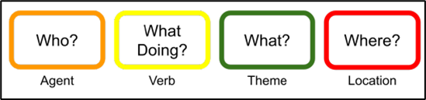

*Figure 1: Colorful Semantics.*

These roles are associated with colors in order to:

1) Make a visual distinction between each semantic role.

2) Enhance the relationship between the question and the semantic role

3) Associate each type of phrase with a visual sequence of colors

5) Alert the child when he omits a semantic role

Colors act as a visual aid to indicate the grammatical structure of a sentence, and questions help to link this structure (syntactic) to its meaning (semantics).

Semantic roles are more significant for individuals with CCN than syntactic functions (i.e., subject, verb, and object).

Its usage is what differentiates CS from other color-coding systems in which the colors refer to grammatical classes (e.g., nouns, verbs, or adjectives).

**(2) Language Acquisition Through Motor Planning (LAMP):**

Language Acquisition Through Motor Planning (LAMP) focuses on motor planning and motor memory to support language development. It incorporates consistent motor patterns for each word or phrase on the communication board, making it easier for individuals to access and use.

**(3) Semantic Grammar (SG):**

A Semantic Grammar (SG) (see Figure 2) provides a structured framework for constructing sentences on the communication board. It guides the message authoring process and ensures that the sentences created are semantically accurate and meaningful.

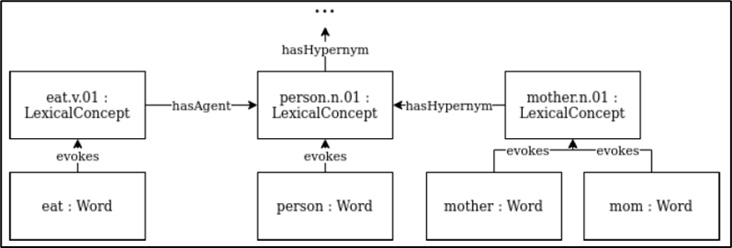

*Figure 2: Semantic Grammar.*

By combining **CS**, **LAMP**, and **SG**, the Semantic ACB enables individuals with CCN to construct meaningful sentences and express their thoughts, needs, and desires effectively. [2]

# 3.2. Related Work

A communication board can be a printed or computerized board that includes a database of pictures, illustrations, symbols, letters or words. One of the most common and most suitable of all of the available existing computerized solutions is the “TouchChat” application [4].

An alternative solution is “Grid3” (<https://thinksmartbox.com/product/grid-3/>), which provides a range of accessibility modules, including an AAC board. To use the application a one-time purchase is required. Communication boards can be downloaded through another website called “OnlineGrids”

(<https://grids.sensorysoftware.com/he>).

Table 1: Pros and cons of the existing solutions: “TouchChat” and “Grid3”:

|  |  |  |
| --- | --- | --- |
| **Solution** | **Pros** | **Cons** |
| **TouchChat**  **Grid3** | 1) Can be customized to meet the specific needs of each user, allowing for a personalized communication solution.  2) Good for early communication  3) Supports Hebrew language  4) Multiple modes of communication: supports various modes of communication, including text-to-speech, symbol-based communication, and image-based communication.  1) The application provides support for the Hebrew language.  2) The application allows users to freely download boards without any cost  3) The application includes a quiz feature where users can engage in quiz related activities  4)The application provides the option to back up boards on the cloud | 1) Available only for iOS devices:  iPad / iPod/ iPhone - not supporting Android users.  2) The design of the application can be more child-user-friendly, so a child will be more independent in using it without needing the assistance of an adult.  3) The application interface can appear to be very busy also for adults. The UI is not very easy to use and can be very time-consuming.  4) The app isn’t free, therefore not affordable for everyone - the cost is 899.90 NIS, one-time purchase.  5) There is no option to create user profiles, therefore there is no option to access the customized communication board for different users from different devices.  6) There is no training feature.  1) The application is not available for free. It requires a monthly subscription of £10 or a one-time payment of £400, which is approximately 50 NIS per month or 2000 NIS as a one-time payment.  2) In order to incorporate additional boards, they need to be initially downloaded onto a computer from a different site and then manually transferred from the computer to the tablet  3) The ability to create custom boards is unavailable, so users must instead download predefined boards from a specific set    4) Accessing the communication board on the app requires navigating through multiple menus instead of being readily available  5) There is no option to create user profiles, therefore accessing a customized communication board for different users on the same device is not available |

# 4. Expected Achievements

Our goal is to develop an augmentative communication application that will allow children with complex communication needs to express themselves more effectively. The application will feature a simple interface, especially designed for children, with a range of categories that the child can choose from to find the right words for their sentence. The selection of words will be arranged in such a way that they form correct grammatical sentences when used together.

Once the child selects the appropriate words, the application will provide a clear visual representation of the sentence. The child can press a button to have the application speak the sentence aloud for him. Our communication application will be designed to be easily portable and customizable to the needs of the child. We will offer a range of different categories and symbols to choose from, and the application will allow to add new categories or symbols as needed. Each child will have his own personalized account that will store their personalized communication boards. This will allow them to use their own boards from any device.

Success criterion for our project will be:

1. Effective communication and independence: The child's ability to effectively communicate with his surroundings independently will be improved by using our application.

2. Long-term impact: The project should have a lasting impact on the child's development, providing benefits that extend beyond the duration of their engagement with the application.

3. User satisfaction: Feedback from both the child and the adult users should indicate a high level of satisfaction with the application, including its usability, features, and overall experience.

**Flow Chart:**

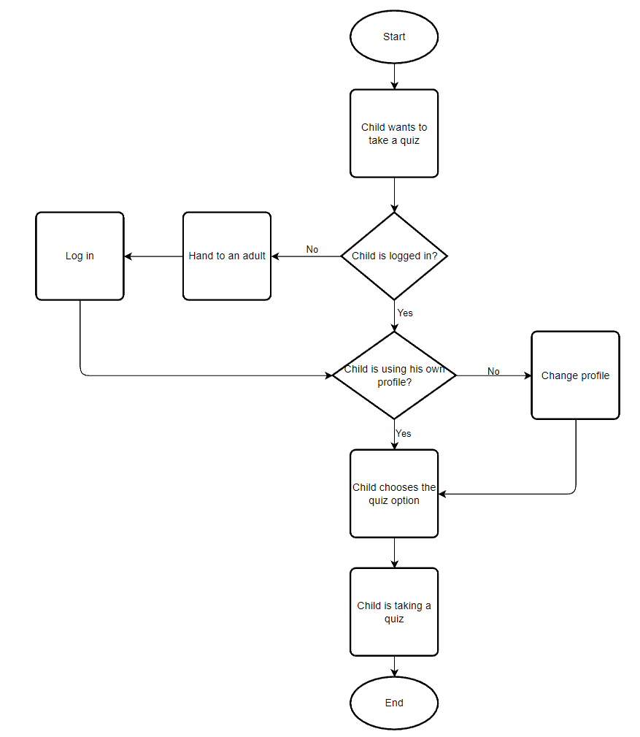

# 5. Research and Engineering Process

# 5.1. Process

Our engineering process began with a meeting with a kindergarten teacher and a speech therapist in “Askol Gani Yuvalin” Kindergarten Campus, located in Upper Afula, that currently helps children with their communication skills. During the meeting they showed us the current application used by the children to communicate and told us the problems they encountered while working with it. One major problem is the very high price leading for this application to be out of some children's reach. They also suggested that such an application should be free to use.

Then we defined our system’s requirements and started thinking about what more than just a better price we can do. We thought about a better user interface that children would find more pleasing, a better way for the children to construct a sentence using specific color for each type of word (nouns, verbs ,etc..) and a way for that children to test themselves to improve their language. Then we started to design the prototype and prepared the testing plan. During the semester and as we made progress, we realized that we need to face the following challenges:

Learning new software environments and programming languages (see Figure 3):

* Google Text-to-Speech API - converts text into spoken audio, offering a wide range of voices.
* Mobile app development - using React Native framework to build mobile applications for both iOS and Android platforms.
* Google Sign-In services - enable users to securely sign up or log in using their Google accounts.
* Google Cloud - Cloud based Database.
* NLP libraries - to categorize words to lexical categories.
* Server Communication – NodeJS

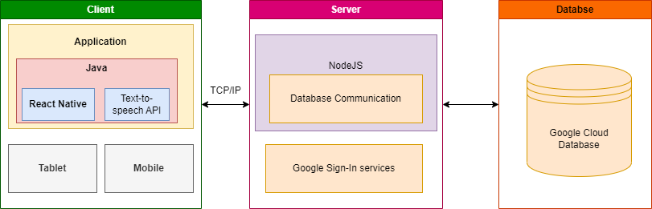

*Figure 3: System's Architecture.*

**The main requirements of our system are:**

* The system should support Hebrew
* The system should be compatible with both iOS and Android platforms.

The system should allow users to:

* log in
* log out
* register
* create board categories
* edit board categories
* choose words for a sentence
* play word and sentences aloud
* edit sentences
* add sentences to favorites
* add quiz questions
* add answers for quiz questions
* create quiz
* take a quiz
* edit a quiz
* create profiles
* edit profiles
* edit the system settings
* check a child’s progress

# 5.2. Product

Our system is a solution that will help children with communication needs to speak and express themselves, by choosing the word they would like to say.

In the following sections we will describe the core components of our product.

# 5.3. Diagrams

# 5.3.1. Use Case

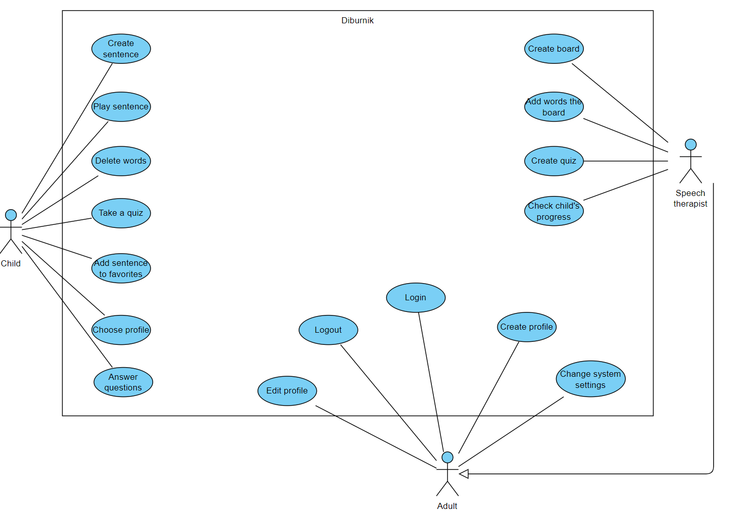

# 

# 

# 

|  |  |  |  |  |  |
| --- | --- | --- | --- | --- | --- |
| **Check progress** | **Create board** | **Choose profile** | **Take a quiz** | **Create sentence** | **Use Case** |
| The speech therapist can see the progress of all the kids in the kindergarten based on the quizzes they take | The speech therapist adds boards categories to the children’s profile based on their communication level | In order to interact with his own boards and to continue being monitored by the speech therapist the child selects his profile from the profile list | The child has to construct a legit sentence using the words on the screen and the application will check the answer and give feedback | The child chooses the word he would like to say in the right order | Description |
| Speech therapist | Speech therapist | Child | Child | Child | Actors |
| The speech therapist enters the progress option | The speech therapist presses on add new board | The child presses on the profile picture | The child presses to take a quiz | The child presses a category | Triggers |
| The child has done at least one quiz | The child has his own profile | The child’s profile has been added to the kindergarten’s profiles | The child has his own profile | There is at least one board in the child’s profile | Initial Conditions |
| 1.The speech therapist enters the progress menu  2.The system shows list of kids who has a profile  3.The speech therapist selects a child  4.The system shows the progress on each quiz  5.The speech therapist finds out the subjects the child is struggling with | 1.The speech therapist selects which profile to add a board to  2.The system shows an empty board  3.Based on the child’s communication level the therapist adds the boards | 1.The child presses on the profile picture  2.The system shows existing profiles  3.The child selects his picture from the list | 1.The system generate a quiz  2.The child answers the questions  3.The system shows feedback  4.The data is gathered for progress monitoring | 1.The child chooses the category of words  2.The system shows available word  3.The child chooses the word he wants to say  4.The child creates a sentence using the words | Successful Scenario |
| The child hasn't done any quizzes yet | The child doesn't have a profile yet | The child can’t find himself on the list, because doesn't have a profile yet | There are no quizzes yet in the system, so no quizzes can be done | The child can't find the words he is looking for | Alternative Scenarios |

### 

# 5.3.2. Activity Diagram

Taking a quiz

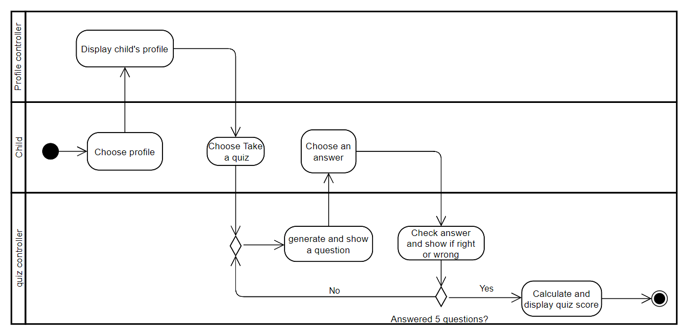

# 5.3.4. GUI Prototype

Below, is a GUI Prototype that demonstrates the design of the main application's pages:

**‘Login’ screen:** This will be the initial screen that opens after installing the application on the device.

For users who already have an account, logging into the application requires entering their username and password. In case a user forgets his password, he can reset it by utilizing the "Forgot Password" option.

For new users, there is a simple registration process that involves clicking on the "Register Now" option and providing some basic information.

With the login feature, each child can easily access their communication board with his saved information from any Tablet device on which the application is installed.

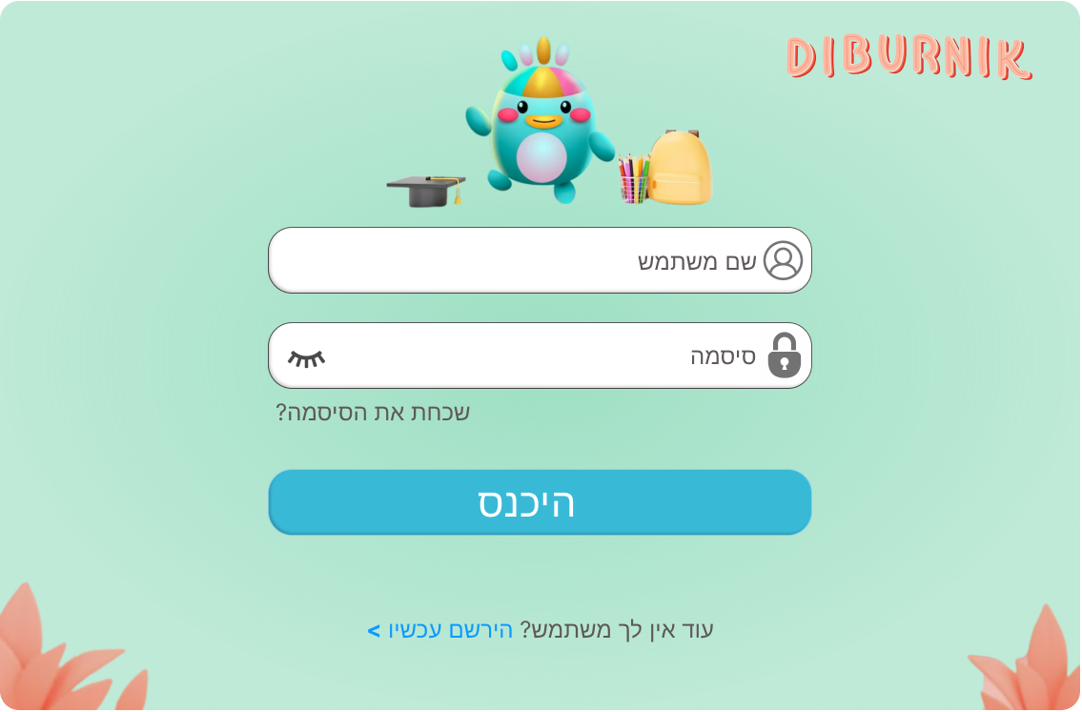

**‘Registration’ screen:**

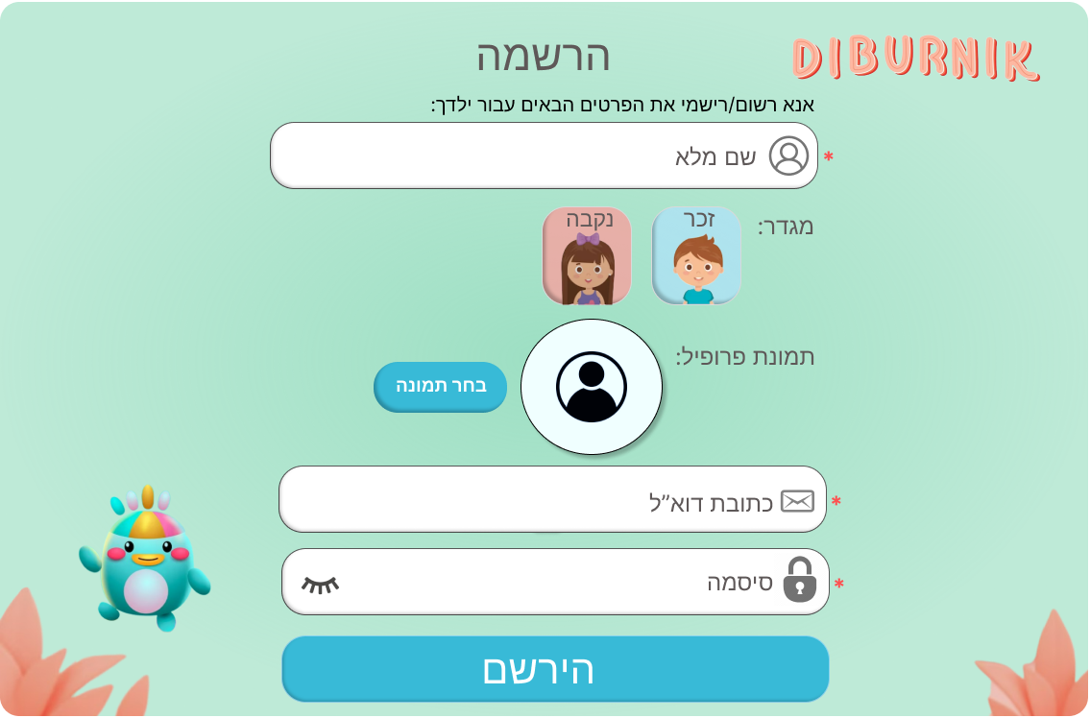

**‘Select Profile’ screen:**

Once at least one user logs in and clicks on the app icon, the initial screen displayed will be the 'Select Profile' screen.

The screen displays a list of user profiles that have been logged into the application on the current device. Each profile includes the user's name and profile picture.

This convenient feature allows for easy switching between profiles without the need for repeated sign-ins. Additionally, there is a search option available to find a user by his name.

Upon selecting a profile, the user will be directed to a personalized communication board that includes development-appropriate vocabulary and phrases relevant to the child's interests and unique communication needs.

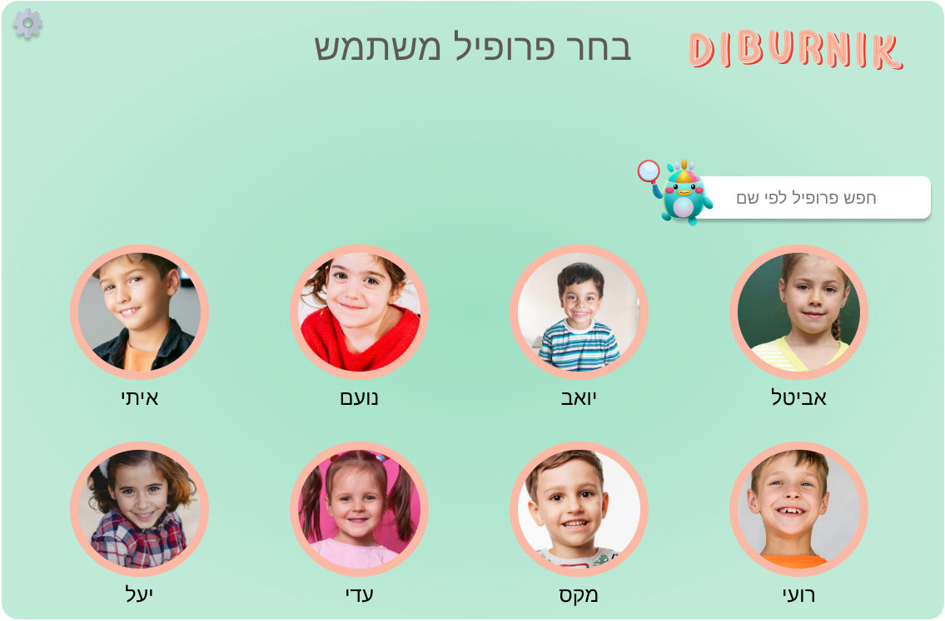

There is an option to enter into ‘Edit mode’. This can be done by pressing on the ‘Setting’ icon that is located at the top left corner of the screen.

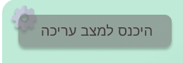

**‘Entering into edit mode’ screen:**

To prevent accidental access to edit mode by children, the following screen will be displayed after clicking on “Enter into edit mode”. On this screen, instructions for password entry will be written in order to ensure that only literate adults can enter into this mode. Each time the screen is accessed, the instructions will be randomly generated.

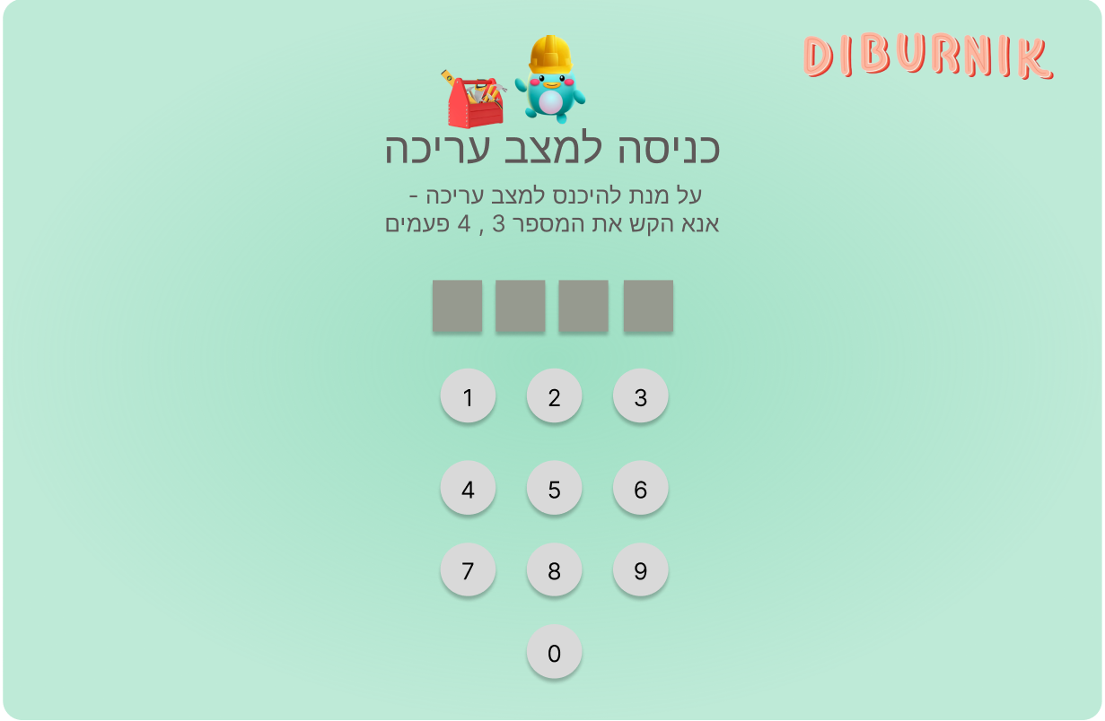

**‘Edit Profile’ screen:**

In edit mode, the user can edit profiles , remove profiles from the current device (will only remove it locally ,the profile will still be accessible from other devices), or add a new account to the device (by performing a log-in or sign-up process).

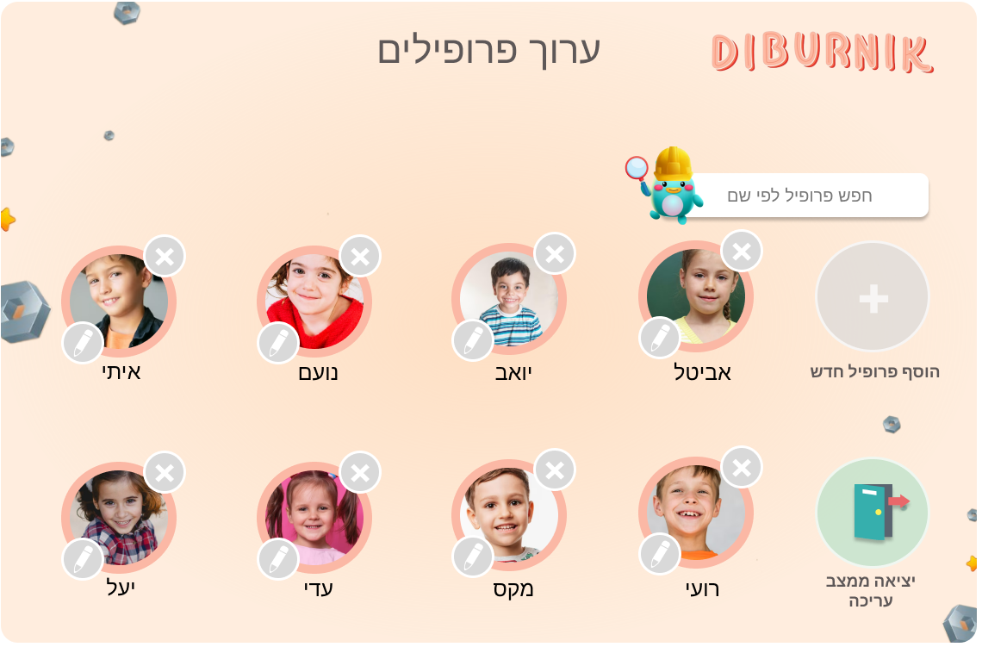

**Main Communication Board screen:** The main communication board screen displays a list of communication boards that were created and customized (by parents/ therapists) tailored to each child's unique needs and interests.

Each board has a representing picture and a title. Clicking on a board opens it for the child to view, while the board's title is announced. This makes it easy for the child to access and explore his boards independently.

The application allows to add any needed amount of communication boards. In cases where all boards cannot be displayed on a single page, the child can use navigation options such as arrows or sliding to view additional boards.

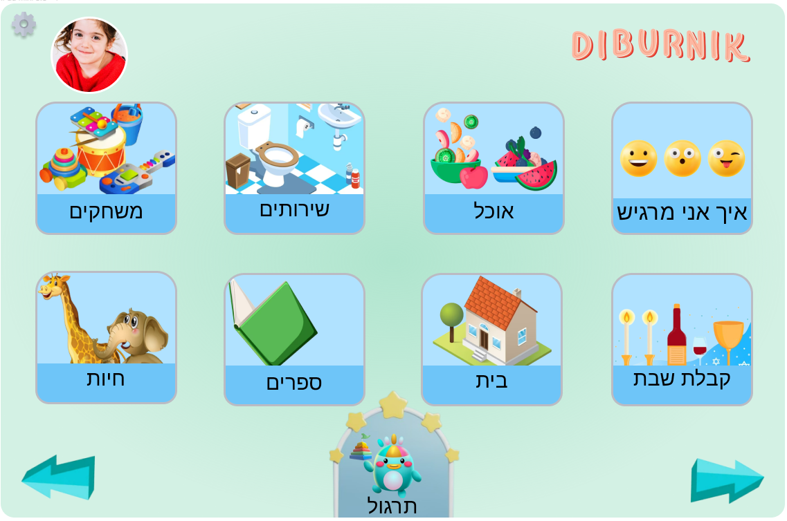

At the middle-bottom of the screen, there is a special button leading the kids to a fun and educational learning and training area.



**Select Quiz screen:**

There is an option for the children to take quizzes in various subjects that were taught during their time in kindergarten.

These quizzes are created by kindergartens and speech and language therapist, ensuring that the content aligns with the educational curriculum.

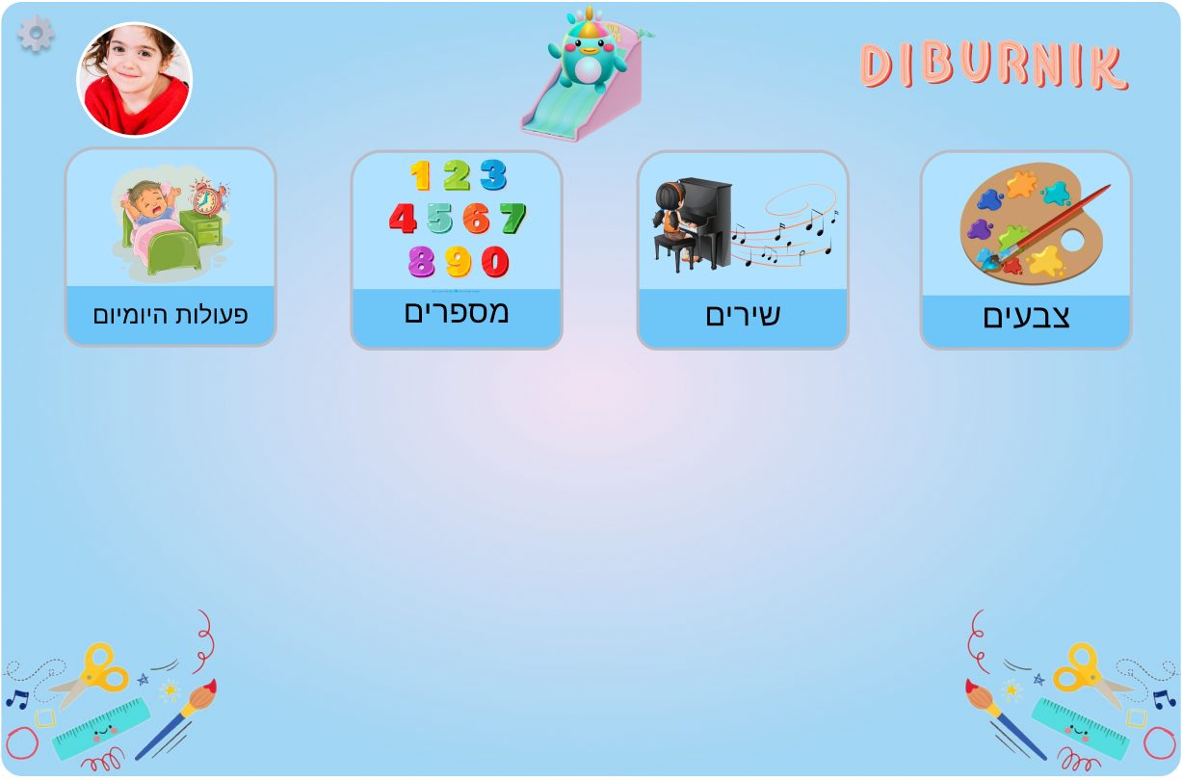

**Take a Quiz screen:**

There is an option for the children to take quizzes in various subjects that were taught during their time in kindergarten.

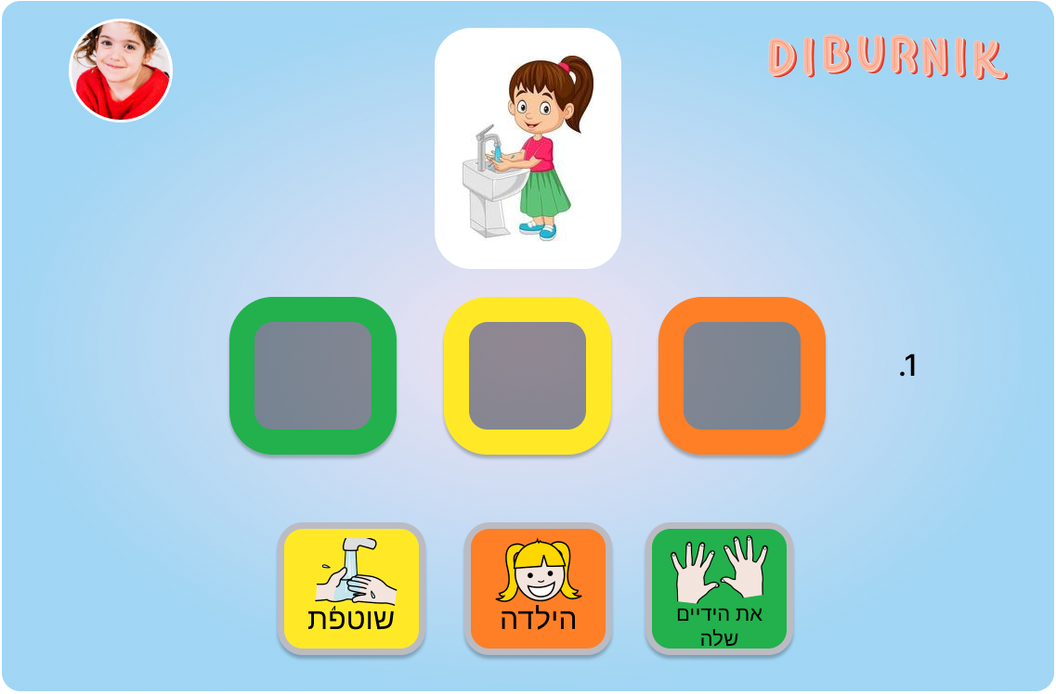

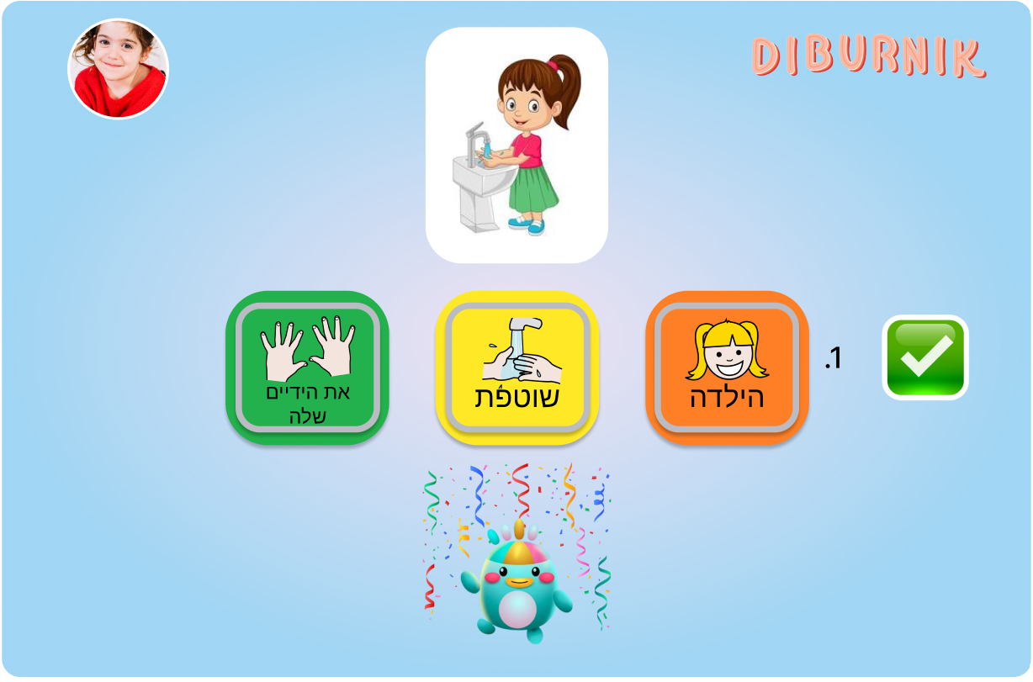

**“Track child’s process” screen:**

The speaking therapist will have the opportunity to manually adjust the child's knowledge level for each topic, ranging from 1 to 5. Through observation of the child's responses during the quiz, the therapist will acquire valuable insights. Armed with this information, the therapist will proceed to update the child's progress in the table accordingly.

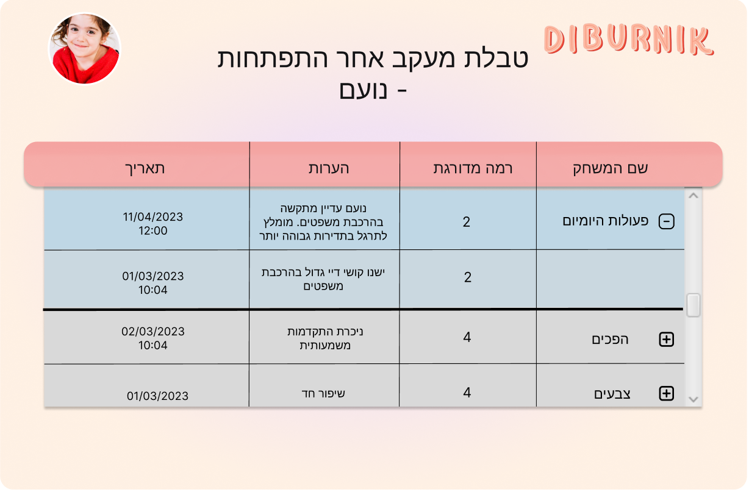

**‘Edit mode’ screen:** There is an option to either edit ,delete or create a new communication board. Entering edit mode is possible as was described previously.

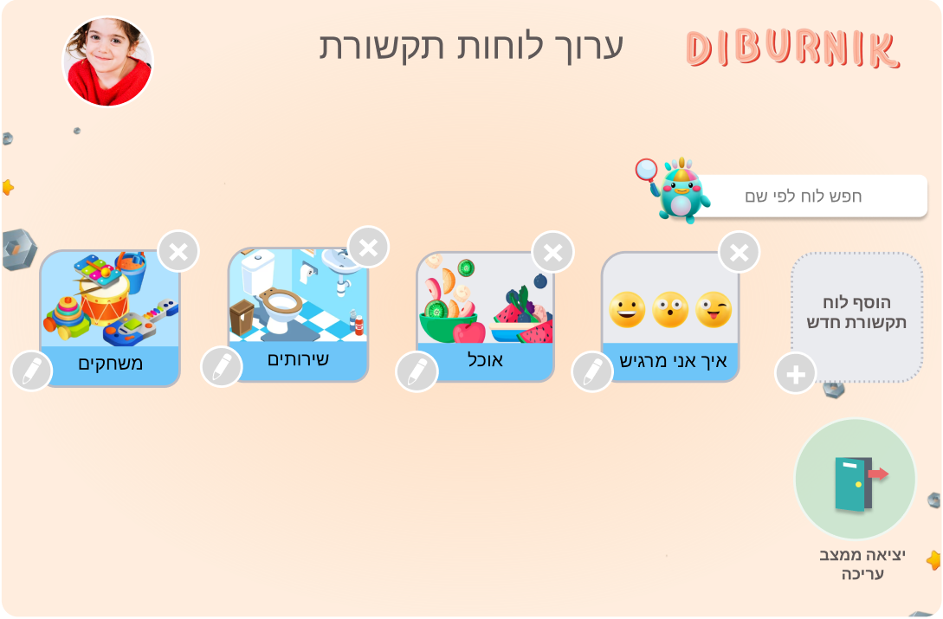

**‘Add New Communication Board’ screen:** After pressing on ‘Add New Communication Board’ - an empty communication board will open. There will be an option to edit the name of the board and to add new cells to the board. Each cell will require a title , image and audio.

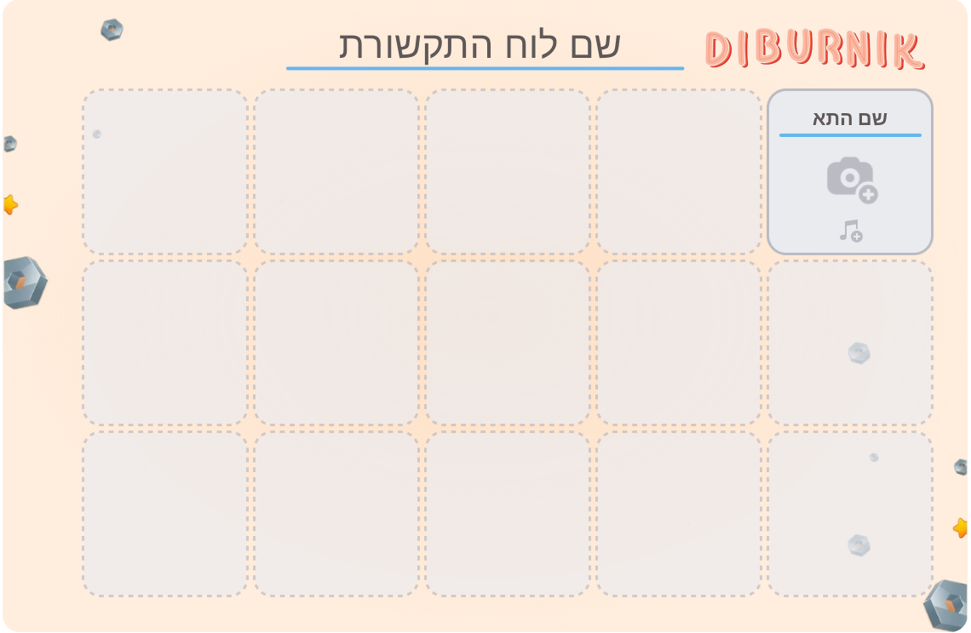

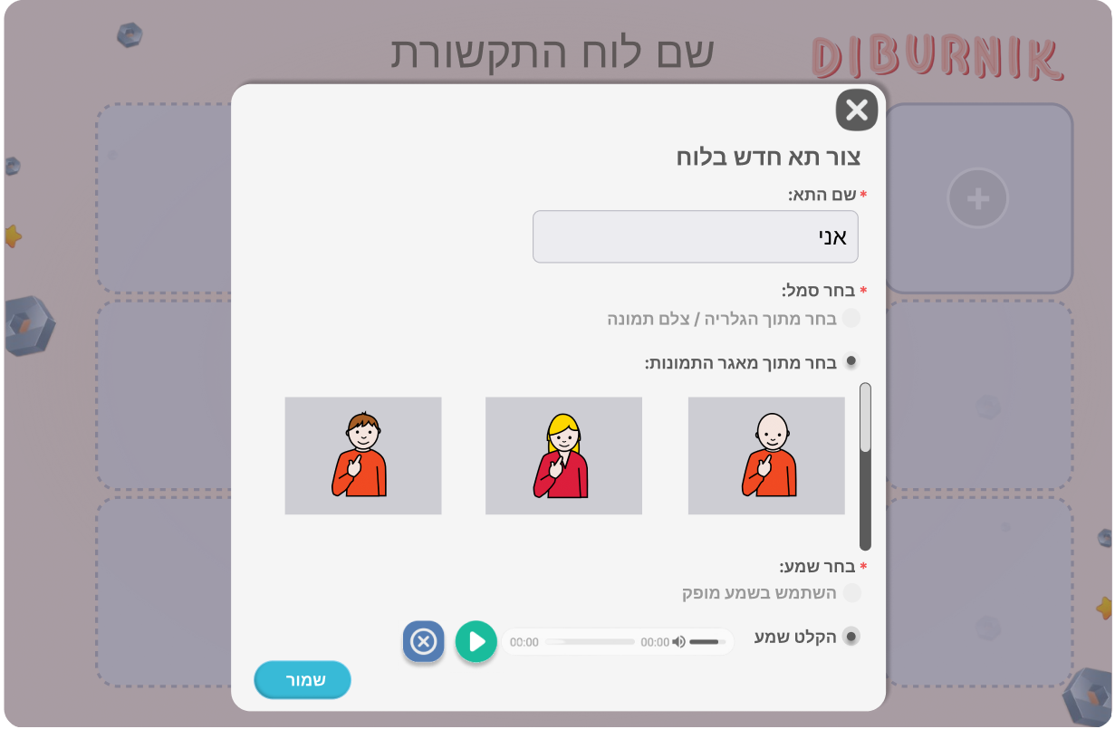

‘**Communication Board’ screen:**

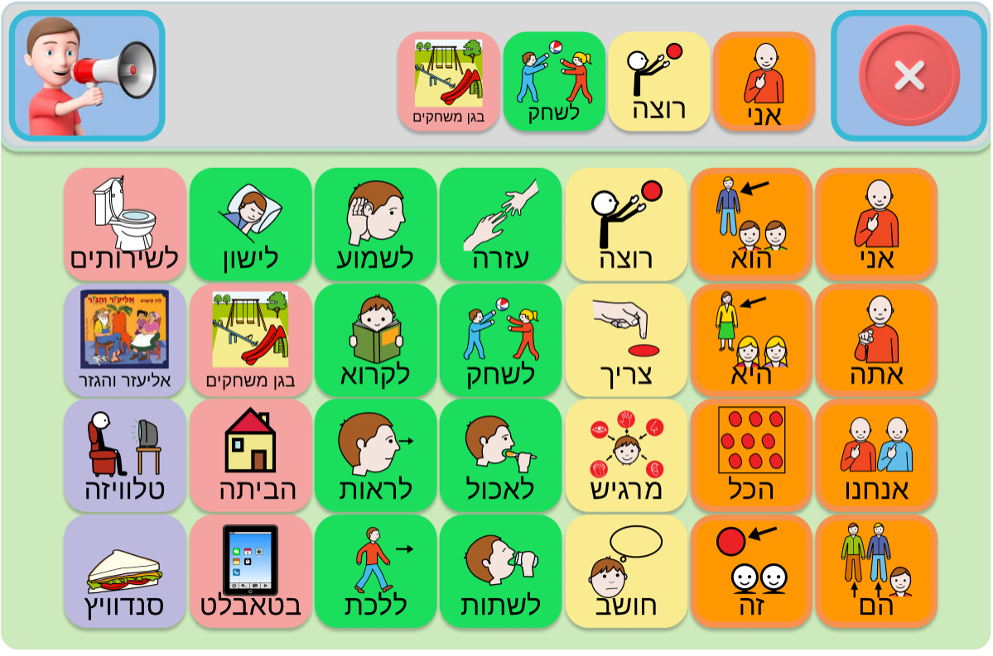

# 6. Evaluation / Verification Plan

Our evaluation and verification plan involves:

1. Running a testing plan.
2. Evaluate our application by giving it to be used by our end-users:

* A speech therapist who specializes in working with children who have complex communication needs.
* A child with special communication needs , providing him with suitable support from his speech therapist.

# 6.1 Testing Plan

|  |  |  |  |
| --- | --- | --- | --- |
| **Test Number** | **Test Subject** | **Test Headline** | **Expected Result** |
| **1** | Login | The adult enters login detail and clicks login | The adult is logged in to the kindergarten profile |
| **2** | Create sentence | The child builds the sentence he wants to say | The application builds the sentence and displays it at the top of the screen |
| **3** | Play sentence | The child clicks on the speaking button | The application plays the sentence aloud |
| **4** | Take a quiz | The child clicks on take a quiz and answers questions | The application shows a quiz with questions and shows the child if he is right or wrong |
| **5** | Add sentence to favorites | The child builds a sentence and click on save to favorites | The sentence has been added to the child’s favorites sentences |
| **6** | Enter edit mode | Press on the edit mode button | The application is now in edit mode |
| **7** | Create board | The speech therapist enters edit mode and click on the + icon to add a new board | A new board is added to the boards list with a proper name(e.g. animals) |
| **8** | Add words | The speech therapist chooses a board and an empty icon, clicks on the + icon and choose the right word and an icon | A new word has been added to the board with a proper icon |
| **9** | Change settings | An adult enters edit mode and click on change settings | The adult can change the application settings(e.g. font size,time to keep tablet awake) |
| **10** | Create quiz | The speech therapist chooses words for each question on the quiz | A quiz was created |
| **11** | Create profile | An adult enters edit mode and clicks on the + icon next to a blank space and chooses a name and a picture | The adult can now add a new child profile with the child’s name and picture |
| **12** | Edit profile | An adult enters edit mode and click on the edit icon next to a child’s picture | The adult can change the details about the child |
| **13** | Check progress | The speech therapist clicks on the progress tab and chooses a child | The speech therapist can check the progress of the child |
| **14** | Take a quiz | A child press on “take on quiz” and answer the questions | The app gives feedback to the child |

# 6.2 Evaluation by User

We will collaborate with “Eshkol Geni Yuvalim”, a kindergarten

campus , located in Upper Afula. The campus is a home for children between the ages of 3 and 7 who have complex disabilities such as: cerebral palsy and /or developmental delays of varying levels.

We will evaluate our application with the assistance of:

1. A speech therapist who is working in “Eshkol Geni Yuvalim” and specializes in working with children who have complex communication needs.
2. We will conduct usability testing with a group of children who are part of the "Eshkol Geni Yuvalim" campus. By involving a diverse group of users with different needs and abilities, we can gain a more comprehensive understanding of the usability and effectiveness of our application.
3. We will also involve the parents of the children in the campus to gather feedback on the usability and effectiveness of our application. This will help us to gain insights into how the application can better meet the needs of the children and their families.

# 7. References

1. [**https://en.wikipedia.org/wiki/Augmentative_and_alternative_communication**](https://en.wikipedia.org/wiki/Augmentative_and_alternative_communication)
2. Pereira, J.A., Pereira, J.A., & Fidalgo, R.N. (Year). Caregivers Acceptance of Using Semantic Communication Boards for Teaching Children with Complex Communication Needs. Centro de Informática - Universidade Federal de Pernambuco (UFPE), Recife, PE, Brazil.

**<https://sol.sbc.org.br/index.php/sbie/article/view/18094/17928>**

1. Light, J., & McNaughton, D. (2011). Supporting the communication, language, and literacy development of children with complex communication needs: state of the science and future research priorities. Assistive technology : the official journal of RESNA, 24(1), 34–44. [**https://doi.org/10.1080/10400435.2011.648717**](https://doi.org/10.1080/10400435.2011.648717)
2. [**https://www.iaccessibility.com/apps/mobility/index.cgi/product?ID=181**](https://www.iaccessibility.com/apps/mobility/index.cgi/product?ID=181)
3. Drager, K., Light, J., & McNaughton, D. (2011). Effects of AAC interventions on communication and language for young children with complex communication needs. Journal of Pediatric Rehabilitation Medicine

[**https://www.researchgate.net/publication/51523624_Effects_of_AAC_interventions_on_communication_and_language_for_young_children_with_complex_communication_needs**](https://www.researchgate.net/publication/51523624_Effects_of_AAC_interventions_on_communication_and_language_for_young_children_with_complex_communication_needs)

1. Light, J., & Drager, K. D. (2007). AAC technologies for young children with complex communication needs: State of the science and future research directions. Augmentative and Alternative Communication

[**https://www.academia.edu/7487746/AAC_technologies_for_young_children**](https://www.academia.edu/7487746/AAC_technologies_for_young_children)